**Data File Structures**

**Lab File**



Submitted By – Ajay Ravesh

Roll No - 53

INDEX

|  |  |  |  |  |
| --- | --- | --- | --- | --- |
| S.No | LAB EXERCISES | TOPIC | DATE | SIGN |
| **1** | **LAB EXERCISE 1** | **MATRIX MULTIPLICATION** | **25-4-22** |  |
| **2** | **LAB EXERCISE 2** | **LINEAR SEARCH** | **25-4-22** |  |
| **3** | **LAB EXERCISE 3** | **BUBBLE SORT** | **25-4-22** |  |
| **4** | **LAB EXERCISE 4** | **MATRIX TRANSPOSE** | **25-4-22** |  |
| **5** | **LAB EXERCISE 5** | **STACK** | **2-5-22** |  |
| **6** | **LAB EXERCISE 6** | **QUEUE** | **2-5-22** |  |
| **7** | **LAB EXERCISE 7** | **FACTORIAL OF NUMBER** | **2-5-22** |  |
| **8** | **LAB EXERCISE 8** | **FIBONACCI SERIES** | **2-5-22** |  |
| **9** | **LAB EXERCISE 9** | **BINARY SEARCH** | **9-5-22** |  |
| **10** | **LAB EXERCISE 10** | **INSERTION SORT** | **9-5-22** |  |
| **11** | **LAB EXERCISE 11** | **SELECTION SORT** | **9-5-22** |  |
| **12** | **LAB EXERCISE 12** | **LINKED LIST** | **16-5-22** |  |
| **13** | **LAB EXERCISE 13** | **MERGE SORT** | **18-5-22** |  |
| **14** | **LAB EXERCISE 14** | **QUICK SORT** | **18-5-22** |  |
| **15** | **LAB EXERCISE 15** | **QUEUE USING STACK** | **23-5-22** |  |
| **16** | **LAB EXERCISE 16** | **BINARY TREE** | **25-5-22** |  |
| **17** | **LAB EXERCISE 17** | **BFS TRAVERSAL** | **13-6-22** |  |
| **18** | **LAB EXERCISE 18** | **DFS TRAVERSAL** | **13-6-22** |  |
| **19** | **LAB EXERCISE 19** | **PRIM’S ALGORITHM** | **20-6-22** |  |
| **20** | **LAB EXERCISE 20** | **KRUSKAL’S ALGORITHM** | **20-6-22** |  |
| **21** | **LAB EXERCISE 21** | **FILE HANDLING IN C** | **27-6-22** |  |
| **22** | **LAB EXERCISE 22** | **FILE HANDLING IN C** | **27-6-22** |  |
| **23** | **LAB EXERCISE 23** | **FILE HANDLING IN C** | **27-6-22** |  |
| **24** | **LAB EXERCISE 24** | **Floyd-Warshall Algorithm** | **4-7-22** |  |

1. Write a program to show multiplication of 2 matrices in C.
2. #include <stdio.h>
3. #include <stdlib.h>
4. #define R1 4
5. #define C1 4
6. #define R2 4
7. #define C2 4
8. void mulMat(int mat1[][C1], int mat2[][C2]) {
9. int rslt[R1][C2];
10. printf("Multiplication of given two matrices is:\n\n");
11. for (int i = 0; i < R1; i++) {
12. for (int j = 0; j < C2; j++) {
13. rslt[i][j] = 0;
14. for (int k = 0; k < R2; k++) {
15. rslt[i][j] += mat1[i][k] * mat2[k][j];
16. }
17. printf("%d\t", rslt[i][j]);
18. }
19. printf("\n");
20. }
21. }
22. int main(void) {
23. int mat1[R1][C1] = {
24. {1, 1, 1, 1},
25. {2, 2, 2, 2},
26. {3, 3, 3, 3},
27. {4, 4, 4, 4}
28. };
29. int mat2[R2][C2] = {
30. {1, 1, 1, 1},
31. {2, 2, 2, 2},
32. {3, 3, 3, 3},
33. {4, 4, 4, 4}
34. };
35. if (C1 != R2) {
36. printf("The number of columns in Matrix-1 must be equal to the number of rows in "
37. "Matrix-2\n");
38. printf("Please update MACROs value according to your array dimension in "
39. "#define section\n");
40. exit(EXIT_FAILURE);
41. }
42. mulMat(mat1, mat2);
43. return 0;
44. }

**OUTPUT :**

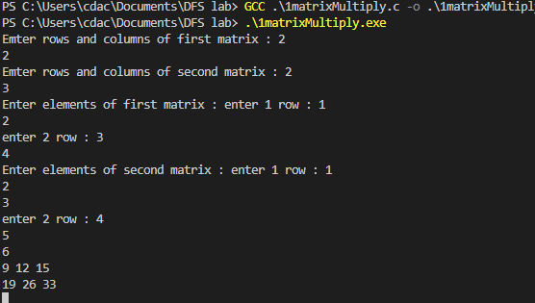

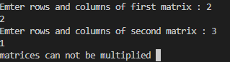

2. Write a Program in C to transpose a square matrix .

#include <stdio.h>

#define N 4

void transpose(int A[][N], int B[][N])

{

    int i, j;

    for (i = 0; i < N; i++)

        for (j = 0; j < N; j++)

            B[i][j] = A[j][i];

}

int main()

{

    int A[N][N] = { {1, 1, 1, 1},

                    {2, 2, 2, 2},

                    {3, 3, 3, 3},

                    {4, 4, 4, 4}};

    int B[N][N], i, j;

    transpose(A, B);

    printf("Result matrix is \n");

    for (i = 0; i < N; i++)

    {

        for (j = 0; j < N; j++)

        printf("%d ", B[i][j]);

        printf("\n");

    }

    return 0;

}

**OUTPUT:**

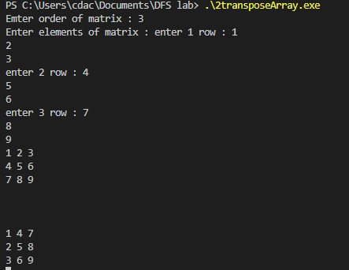

3. Write a program in C to implement Linear Search.

#include <stdio.h>

#include <stdlib.h>

#include <string.h>

int linear_search(int arr[], int length, int key)

{

    int i;

    for(i = 0; i<length; i++){

        if(arr[i] == key ){

            return i;

        }

    }

    return -1;

}

int main()

{

    int arr[] = {1,5,12,14,76,32,54,2,15};

    int key;

    printf("enter the value you want to search in the array : ");

    scanf("%d", &key);

    printf("%d",linear_search(arr, sizeof(arr)/4, key));

}

**OUTPUT:**

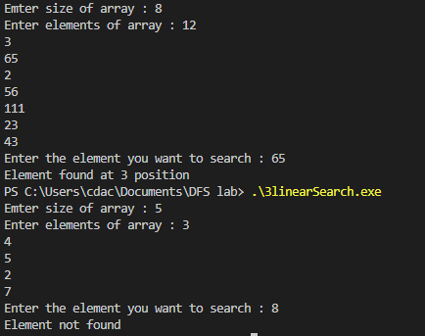

4. write a program in C to implement Bubble Sort.

#include <stdio.h>

#include <stdlib.h>

void bubble_sort(int arr[],int length)

{

    int i;

    int j;

    for(i =0; i < length; i++){

        for(j = 0; j<length-1; j++){

            if(arr[j] > arr[j+1]){

                int temp = arr[j];

                arr[j] = arr[j+1];

                arr[j+1] = temp;

            }

        }

    }

}

int main()

{

    int i;

    int arr[] = {2,6,1,5,45,21,32};

    int length = sizeof(arr)/4;//use sizeof() in main function and not in user defined function.

    bubble_sort(arr,length);

    for(i = 0; i < length; i++){

        printf("%d \t" , arr[i]);

    }

}

**OUTPUT:**

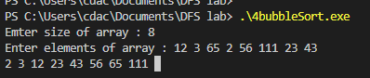

5. Write a program to implement a stack and its operations using an array in C.

// C program for array implementation of stack

#include <limits.h>

#include <stdio.h>

#include <stdlib.h>

// A structure to represent a stack

struct Stack {

    int top;

    unsigned capacity;

    int* array;

};

// function to create a stack of given capacity. It initializes size of

// stack as 0

struct Stack* createStack(unsigned capacity)

{

    struct Stack* stack = (struct Stack*)malloc(sizeof(struct Stack));

    stack->capacity = capacity;

    stack->top = -1;

    stack->array = (int*)malloc(stack->capacity * sizeof(int));

    return stack;

}

// Stack is full when top is equal to the last index

int isFull(struct Stack* stack)

{

    return stack->top == stack->capacity - 1;

}

// Stack is empty when top is equal to -1

int isEmpty(struct Stack* stack)

{

    return stack->top == -1;

}

// Function to add an item to stack. It increases top by 1

void push(struct Stack* stack, int item)

{

    if (isFull(stack))

        return;

    stack->array[++stack->top] = item;

    printf("%d pushed to stack\n", item);

}

// Function to remove an item from stack. It decreases top by 1

int pop(struct Stack* stack)

{

    if (isEmpty(stack))

        return INT_MIN;

    return stack->array[stack->top--];

}

// Function to return the top from stack without removing it

int peek(struct Stack* stack)

{

    if (isEmpty(stack))

        return INT_MIN;

    return stack->array[stack->top];

}

// Driver program to test above functions

int main()

{

    struct Stack* stack = createStack(100);

    push(stack, 10);

    push(stack, 20);

    push(stack, 30);

    printf("%d popped from stack\n", pop(stack));

    return 0;

}

**OUTPUT:**

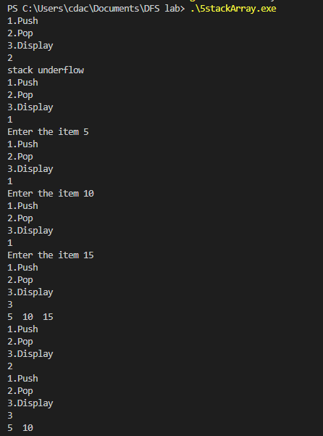

6. Write a program to implement a Queue and its operations using an array.

// C program for array implementation of queue

#include <limits.h>

#include <stdio.h>

#include <stdlib.h>

// A structure to represent a queue

struct Queue {

    int front, rear, size;

    unsigned capacity;

    int* array;

};

// function to create a queue

// of given capacity.

// It initializes size of queue as 0

struct Queue* createQueue(unsigned capacity)

{

    struct Queue* queue = (struct Queue*)malloc(

        sizeof(struct Queue));

    queue->capacity = capacity;

    queue->front = queue->size = 0;

    // This is important, see the enqueue

    queue->rear = capacity - 1;

    queue->array = (int*)malloc(

        queue->capacity * sizeof(int));

    return queue;

}

// Queue is full when size becomes

// equal to the capacity

int isFull(struct Queue* queue)

{

    return (queue->size == queue->capacity);

}

// Queue is empty when size is 0

int isEmpty(struct Queue* queue)

{

    return (queue->size == 0);

}

// Function to add an item to the queue.

// It changes rear and size

void enqueue(struct Queue* queue, int item)

{

    if (isFull(queue))

        return;

    queue->rear = (queue->rear + 1)

                % queue->capacity;

    queue->array[queue->rear] = item;

    queue->size = queue->size + 1;

    printf("%d enqueued to queue\n", item);

}

// Function to remove an item from queue.

// It changes front and size

int dequeue(struct Queue* queue)

{

    if (isEmpty(queue))

        return INT_MIN;

    int item = queue->array[queue->front];

    queue->front = (queue->front + 1)

                % queue->capacity;

    queue->size = queue->size - 1;

    return item;

}

// Function to get front of queue

int front(struct Queue* queue)

{

    if (isEmpty(queue))

        return INT_MIN;

    return queue->array[queue->front];

}

// Function to get rear of queue

int rear(struct Queue* queue)

{

    if (isEmpty(queue))

        return INT_MIN;

    return queue->array[queue->rear];

}

// Driver program to test above functions./

int main()

{

    struct Queue* queue = createQueue(1000);

    enqueue(queue, 10);

    enqueue(queue, 20);

    enqueue(queue, 30);

    enqueue(queue, 40);

    printf("%d dequeued from queue\n\n",

        dequeue(queue));

    printf("Front item is %d\n", front(queue));

    printf("Rear item is %d\n", rear(queue));

    return 0;

}

**OUTPUT:**

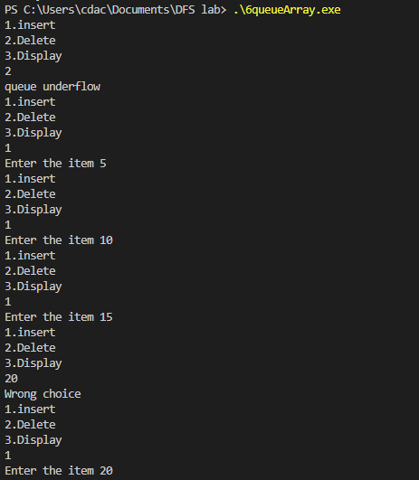

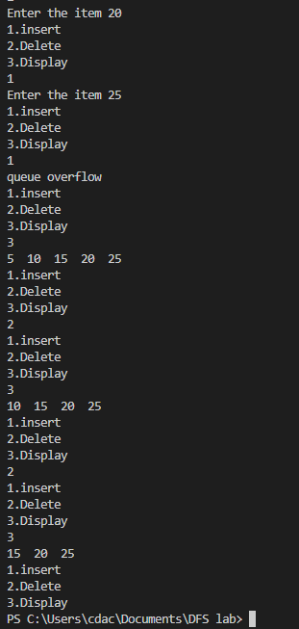

7. Write C program to find factorial of n using :

(i)Recursion

#include <stdio.h>

#include <stdlib.h>

int factorial(int num){

    if (num == 0) //base condition

    {

        return 1;

    }

    int small_ans = factorial(num-1);

    return num * small_ans;

    }

int main()

{

    int num;

    printf("Enter the number to find the factorial : ");

    scanf("%d", &num);

    printf("%d",factorial(num));

}

**OUTPUT:**

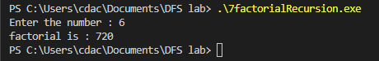

(ii) Iteration

#include <stdio.h>

#include <stdlib.h>

int factorial(int num){

    int result = 1;

    for (int i = 1; i <= num; i++){

        result = result * i;

    }

    return result;

}

int main()

{

    int num;

    printf("Enter the number to find the factorial : ");

    scanf("%d", &num);

    printf("%d",factorial(num));

}

**OUTPUT:**

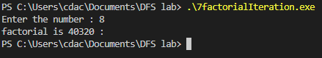

8. Write C programs to compute nth Fibonacci using :

(i) Recursion

#include <stdio.h>

int factorial(int n)

{

    // base case

    if (n == 0)

    {

        return 1;

    }

    else

    {

        return n * factorial(n - 1);

    }

}

int fibbonacci(int n)

{

    if (n == 0)

    {

        return 0;

    }

    else if (n == 1)

    {

        return 1;

    }

    else

    {

        return (fibbonacci(n - 1) + fibbonacci(n - 2));

    }

}

int main()

{

    int n = 5;

    int i;

    printf("Factorial of %d: %d\n", n, factorial(n));

    printf("Fibbonacci of %d: ", n);

    for (i = 0; i < n; i++)

    {

        printf("%d ", fibbonacci(i));

    }

}

**OUTPUT:**

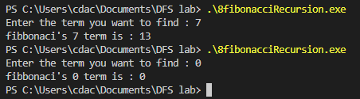

(ii) Iteration

#include <stdio.h>

#include <stdlib.h>

int fibonacci(int num){

    if (num == 1)

    {

        return 0;

    }

    else if (num == 1 || num ==2 )

    {

        return 1;

    }

    int result = 1;

    for (int i = 1; i <= num; i++){

        result = result * i;

    }

    return result;

}

int main()

{

    int num;

    printf("Enter the number to find the factorial : ");

    scanf("%d", &num);

    printf("%d",factorial(num));

}

**OUTPUT:**

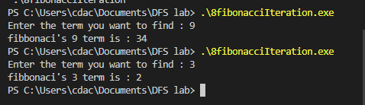

9. Write a program in C to implement Binary Search.

#include <stdio.h>

#include <stdlib.h>

int binary_search(int arr[],int length, int key)

{

    int start = 0;

    int end = length-1;

    while (start <= end){

        int mid = start+(end-start)/2;

        if (key == arr[mid])

        {

            return mid;

        }

        else if (key >= arr[mid])

        {

            start = mid+1;

        }

        else{

            end = mid-1;

        }

    }

    return -1;

}

int main()

{

    int arr[] = {1,3,5,7,8,9,10,13,15,17};//array must be sorted

    int length = sizeof(arr)/4;

    int key;

    printf("enter the value you want to search in the array : ");

    scanf("%d", &key);

    int element_index = binary_search(arr,length,key);

    printf("%d",element_index);

}

**OUTPUT:**

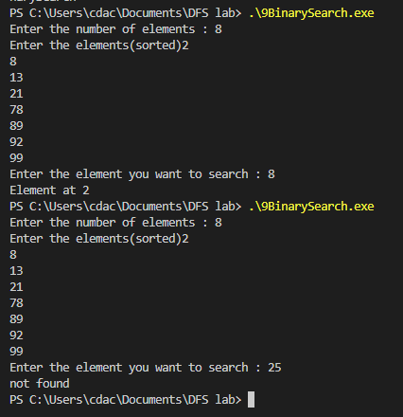

10. Write a program in C to implement Insertion sort.

#include <stdio.h>

#include <stdlib.h>

void insertion_sort(int arr[],int length)

{

    int i;//unsorted

    int j;//sorted

    for(i = 1; i < length; i++){

        j = i-1;

        int temp = arr[i];//storing unsorted element in temp

        while (j >= 0 && arr[j] > temp )//shifting towards right

        {

            arr[j+1] = arr[j];//shifting sorted

            j--;

        }

        arr[j+1] = temp;//making unsorted element as sorted

    }

}

int main()

{

    int i;

    int arr[] = {2,6,1,5,45,21,32};

    int length = sizeof(arr)/4;//use sizeof() in main function and not in user defined function.

    insertion_sort(arr,length);

    for(i = 0; i < length; i++){

        printf("%d \t" , arr[i]);

    }

}

**OUTPUT:**

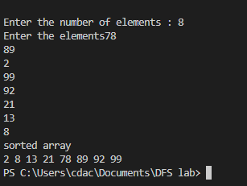

11 . Write a program in C to implement Selection Sort.

#include <stdio.h>

#include <stdlib.h>

void selection_sort(int arr[], int length){

    int i;

    int j;

        //there will be n-1 rounds 0 to length-2

        for (i = 0; i < length-1; i++) {

            int min = arr[i];

            int currentMinIndex = i;

            for (j = i+1; j < length-1; j++) {//for checking the minimum in the complete array

                if (arr[j] < min){

                    min = arr[j];

                    currentMinIndex =j;

                }

            }

            //swapping

            int temp = arr[i];

            arr[i] = min;

            arr[currentMinIndex] = temp;

        }

    }

int main(){

        int arr[] = {3,1,4,2,6,9};

        int length = sizeof(arr)/4;

        selection_sort(arr,length);

        int i;

        for(i = 0; i < length; i++){

        printf("%d \t" , arr[i]);

    }

}

**OUTPUT:**

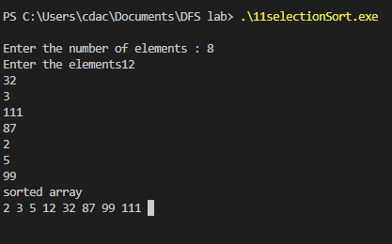

12. Write a program to implement linked list and its operations in C.

#include <stdio.h>

#include <stdlib.h>

struct node

{

    int num;                        //Data of the node

    struct node *nextptr;           //Address of the next node

}*stnode;

void createNodeList(int n); // function to create the list

void displayList();         // function to display the list

int main()

{

    int n;

        printf("\n\n Linked List : To create and display Singly Linked List :\n");

    printf(" Input the number of nodes : ");

    scanf("%d", &n);

    createNodeList(n);

    printf("\n Data entered in the list : \n");

    displayList();

    return 0;

}

void createNodeList(int n)

{

    struct node *fnNode, *tmp;

    int num, i;

    stnode = (struct node *)malloc(sizeof(struct node));

    if(stnode == NULL) //check whether the fnnode is NULL and if so no memory allocation

    {

        printf(" Memory can not be allocated.");

    }

    else

    {

// reads data for the node through keyboard

        printf(" Input data for node 1 : ");

        scanf("%d", &num);

        stnode->num = num;

        stnode->nextptr = NULL; // links the address field to NULL

        tmp = stnode;

// Creating n nodes and adding to linked list

        for(i=2; i<=n; i++)

        {

            fnNode = (struct node *)malloc(sizeof(struct node));

            if(fnNode == NULL)

            {

                printf(" Memory can not be allocated.");

                break;

            }

            else

            {

                printf(" Input data for node %d : ", i);

                scanf(" %d", &num);

                fnNode->num = num;      // links the num field of fnNode with num

                fnNode->nextptr = NULL; // links the address field of fnNode with NULL

                tmp->nextptr = fnNode; // links previous node i.e. tmp to the fnNode

                tmp = tmp->nextptr;

            }

        }

    }

}

void displayList()

{

    struct node *tmp;

    if(stnode == NULL)

    {

        printf(" List is empty.");

    }

    else

    {

        tmp = stnode;

        while(tmp != NULL)

        {

            printf(" Data = %d\n", tmp->num);       // prints the data of current node

            tmp = tmp->nextptr;                     // advances the position of current node

        }

    }

}

**OUTPUT:**

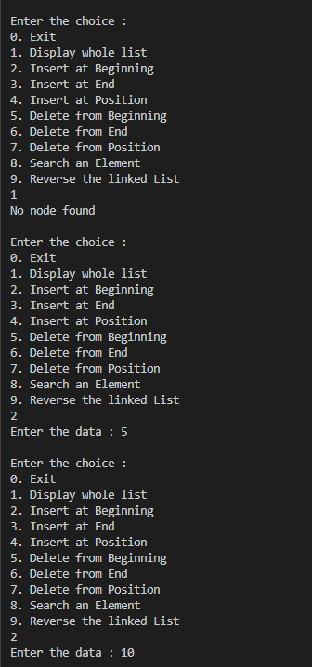

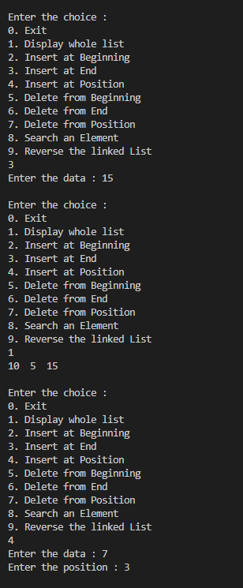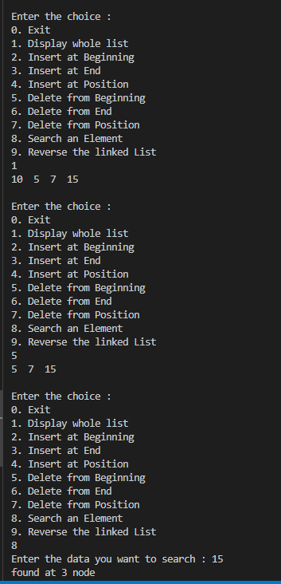

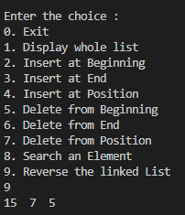

13. Write a program in C to implement merge sort.

#include <stdio.h>

#include <stdlib.h>

// First subarray is arr[l..m]

// Second subarray is arr[m+1..r]

void merge(int arr[], int l, int m, int r)

{

    int i, j, k;

    int n1 = m - l + 1;

    int n2 = r - m;

    //creating temporary arrays

    int L[n1], R[n2];

    //copying to arrays

    for (i = 0; i < n1; i++)

        L[i] = arr[l + i];

    for (j = 0; j < n2; j++)

        R[j] = arr[m + 1 + j];

    //merging the arrays

    i = 0; // Initial index of first subarray

    j = 0; // Initial index of second subarray

    k = l; // Initial index of merged subarray

    while (i < n1 && j < n2) {

        if (L[i] <= R[j]) {

            arr[k] = L[i];

            i++;

        }

        else {

            arr[k] = R[j];

            j++;

        }

        k++;

    }

    //copying leftout elements if any

    while (i < n1) {

        arr[k] = L[i];

        i++;

        k++;

    }

    //copying remaining elements if any

    while (j < n2) {

        arr[k] = R[j];

        j++;

        k++;

    }

}

void mergeSort(int arr[], int l, int r)

{

    if (l < r) {

        // Same as (l+r)/2, but avoids overflow for

        // large l and h

        int m = l + (r - l) / 2;

        // Sort first and second halves

        mergeSort(arr, l, m);

        mergeSort(arr, m + 1, r);

        merge(arr, l, m, r);

    }

}

void printArray(int A[], int size)

{

    int i;

    for (i = 0; i < size; i++)

        printf("%d ", A[i]);

    printf("\n");

}

int main()

{

    int arr[] = { 14,2,56,13,3,8,9,44 };

    int arr_size = sizeof(arr) / sizeof(arr[0]);

    printf("Given array is \n");

    printArray(arr, arr_size);

    mergeSort(arr, 0, arr_size - 1);

    printf("\nSorted array is \n");

    printArray(arr, arr_size);

    return 0;

}

**OUTPUT:**

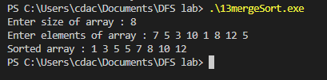

14. Write a program in C to implement quick sort.

#include <stdio.h>

// function to swap elements

void swap(int *a, int *b) {

  int t = *a;

  *a = *b;

  *b = t;

}

// function to find the partition position

int partition(int array[], int low, int high) {

  // select the rightmost element as pivot

  int pivot = array[high];

  // pointer for greater element

  int i = (low - 1);

  // traverse each element of the array

  // compare them with the pivot

  for (int j = low; j < high; j++) {

    if (array[j] <= pivot) {

      // if element smaller than pivot is found

      // swap it with the greater element pointed by i

      i++;

      // swap element at i with element at j

      swap(&array[i], &array[j]);

    }

  }

  // swap the pivot element with the greater element at i

  swap(&array[i + 1], &array[high]);

  // return the partition point

  return (i + 1);

}

void quickSort(int array[], int low, int high) {

  if (low < high) {

    // find the pivot element such that

    // elements smaller than pivot are on left of pivot

    // elements greater than pivot are on right of pivot

    int pi = partition(array, low, high);

    // recursive call on the left of pivot

    quickSort(array, low, pi - 1);

    // recursive call on the right of pivot

    quickSort(array, pi + 1, high);

  }

}

// function to print array elements

void printArray(int array[], int size) {

  for (int i = 0; i < size; ++i) {

    printf("%d  ", array[i]);

  }

  printf("\n");

}

// main function

int main() {

  int data[] = {1,9,2,8,3,7,4,6,0,5};

  int n = sizeof(data) / sizeof(data[0]);

  printf("Unsorted Array\n");

  printArray(data, n);

  // perform quicksort on data

  quickSort(data, 0, n - 1);

  printf("Sorted array in ascending order: \n");

  printArray(data, n);

}

**OUTPUT:**

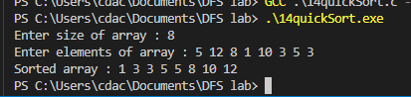

15. write a program in C to implement a queue using 2 stacks.

#include <stdio.h>

#include <stdlib.h>

/* Functions and variables used */

void push1(int);

void push2(int);

int pop1();

int pop2();

void enqueue();

void dequeue();

void display();

void create();

int stack1[100], stack2[100];

int top1 = -1, top2 = -1;

int count = 0;

/* Main Function */

int main()

{

    int choice;

    printf("\nQUEUE USING STACKS IMPLEMENTATION\n\n");

    printf("\n1.ENQUEUE");

    printf("\n2.DEQUEUE");

    printf("\n3.DISPLAY");

    printf("\n4.EXIT");

    printf("\n");

    create();

    while (1)

    {

        printf("\nEnter your choice : ");

        scanf("%d", &choice);

        switch (choice)

        {

        case 1:

            enqueue();

            break;

        case 2:

            dequeue();

            break;

        case 3:

            display();

            break;

        case 4:

            exit(0);

        default:

            printf("\nInvalid Choice\n");

        }

    }

}

/* Function to initialize top of two stacks*/

void create()

{

    top1 = top2 = -1;

}

/* Function to push an element to stack */

void push1(int element)

{

    stack1[++top1] = element; // Pushing the element to stack1

}

/* Function to pop element from stack */

int pop1()

{

    return (stack1[top1--]); // Pop element from stack1

}

/* Function to push an element on to stack */

void push2(int element)

{

    stack2[++top2] = element; // Pushing the element to stack2

}

/* Function to pop an element from stack */

int pop2()

{

    return (stack2[top2--]); // pop element from stack2

}

/* Function to enqueue an element into the queue using stack */

void enqueue()

{

    int data, i;

    printf("Enter the data : ");

    scanf("%d", &data);

    push1(data); // Push data from stack to the queue

    count++;

}

/* Function to dequeue an element from the queue using stack */

void dequeue()

{

    int i;

    for (i = 0; i <= count; i++)

    {

        push2(pop1()); // Pop elements from stack1 and push them to stack2

    }

    pop2(); // Pop the element from stack2 which is the element to be dequeued

    count--;

    for (i = 0; i <= count; i++)

    {

        push1(pop2()); // Push back all the elements from stack2 to stack1

    }

}

/*Function to display the elements in the queue*/

void display()

{

    int i;

    if (top1 == -1)

    {

        printf("\nEMPTY QUEUE\n");

    }

    else

    {

        printf("\nQUEUE ELEMENTS : ");

        for (i = 0; i <= top1; i++)

        {

            printf(" %d ", stack1[i]);

        }

        printf("\n");

    }

}

**OUTPUT:**

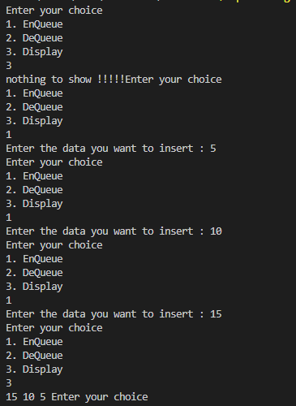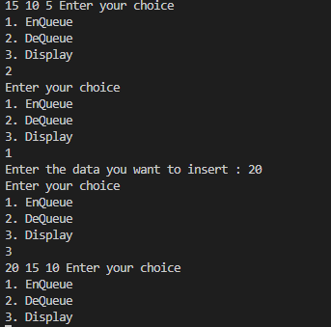

16. Write a program in C to show Tree traversal.

// C program for different tree traversals

#include <stdio.h>

#include <stdlib.h>

/* A binary tree node has data, pointer to left child

and a pointer to right child */

struct node

{

    int data;

    struct node *left;

    struct node *right;

};

/* Helper function that allocates a new node with the

given data and NULL left and right pointers. */

struct node *newNode(int data)

{

    struct node *node = (struct node *)malloc(sizeof(struct node));

    node->data = data;

    node->left = NULL;

    node->right = NULL;

    return (node);

}

/* Given a binary tree, print its nodes according to the

"bottom-up" postorder traversal. */

void printPostorder(struct node *node)

{

    if (node == NULL)

        return;

    // first recur on left subtree

    printPostorder(node->left);

    // then recur on right subtree

    printPostorder(node->right);

    // now deal with the node

    printf("%d ", node->data);

}

/* Given a binary tree, print its nodes in inorder*/

void printInorder(struct node *node)

{

    if (node == NULL)

        return;

    /* first recur on left child */

    printInorder(node->left);

    /* then print the data of node */

    printf("%d ", node->data);

    /* now recur on right child */

    printInorder(node->right);

}

/* Given a binary tree, print its nodes in preorder*/

void printPreorder(struct node *node)

{

    if (node == NULL)

        return;

    /* first print data of node */

    printf("%d ", node->data);

    /* then recur on left subtree */

    printPreorder(node->left);

    /* now recur on right subtree */

    printPreorder(node->right);

}

/* Driver program to test above functions*/

int main()

{

    struct node *root = newNode(1);

    root->left = newNode(2);

    root->right = newNode(3);

    root->left->left = newNode(4);

    root->left->right = newNode(5);

    printf("\nPreorder traversal of binary tree is \n");

    printPreorder(root);

    printf("\nInorder traversal of binary tree is \n");

    printInorder(root);

    printf("\nPostorder traversal of binary tree is \n");

    printPostorder(root);

    getchar();

    return 0;}

**OUTPUT:**

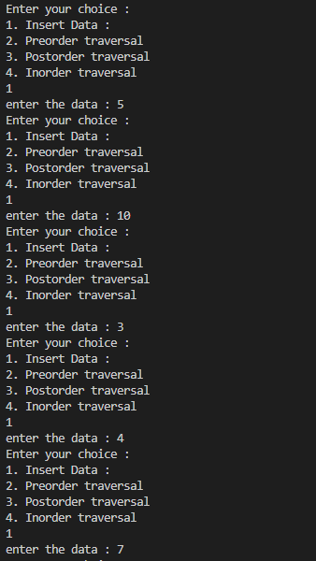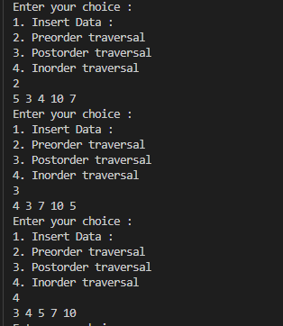

**17.**